OPTIMAL TRACKING FILTERS
By
John Ehlers

INTRODUCTION
Dr. R.E. Kalman introduced his concept of optimum estimation in 1960. Since that time, his technique has proven to be a powerful and practical tool. The approach is particularly well suited for optimizing the performance of modern terrestrial and space navigation systems. Many traders not directly involved in system analysis have heard about Kalman filtering and have expressed an interest in learning more about it for market applications. Although attempts have been made to provide simple, intuitive explanations, none has been completely successful. Almost without exception, descriptions have become mired in the jargon and state-space notation of the “cult”.
Surprisingly, in spite of the obscure-looking mathematics (the most impenetrable of which can be found in Dr. Kalman’s original paper), Kalman filtering is a fairly direct and simple concept. In the spirit of being pragmatic, we will not deal with the full-blown matrix equations in this description and we will be less than rigorous in the application to trading. Rigorous application requires knowledge of the probability distributions of the statistics. Nonetheless we end with practically useful results. We will depart from the classical approach by working backwards from Exponential Moving Averages. In this process, we introduce a way to create a nearly zero lag moving average. From there, we will use the concept of a Tracking Index that optimizes the filter tracking for the given uncertainty in price movement and the uncertainty in our ability to measure it.

SUB-OPTIMAL FILTERS
Tracking filters are used to estimate the position of a target using a linear model. Equation 1, called an Alpha filter, shows that this model is comprised of using the previous estimate plus a constant times the difference between the last real position and the last estimate.

- X^ = X^[1] + α(Z – X^[1])
Where X^ is the estimated next position
Z is the last real position

But this is exactly the same thing as the Exponential Moving Average (EMA) with which you are familiar. I prefer to rearrange the terms so that the EMA is written as:

- EMA = α*Price + (1 – α)*EMA[1]

As you know, this equation for the EMA produces a lag in the estimated price. We can improve our estimate of position by adding an estimate of the velocity to the last known position in Equation 1. Equation 1 then becomes:

- X^ = X^[1] + α((Z + K*V^) – X^[1])
Where V^ is the velocity estimate
K is a gain factor

In general, the velocity estimate is an EMA of the rate of change of position, so that:

- V^ = V^[1] + β(V – V^[1])

This is the Beta part of an Alpha-Beta filter.
We can create a near zero lag filter for the special case where b = 1. In this case, equation 2 can be written as:

- ZEMA = α*(Price + K*(Price – Price[4])) + (1 – α)*ZEMA[1]

I took the liberty of using the four day “Momentum” (a misnomer if ever there was one) as the velocity estimate. Figure 1 shows the EMA using α = 0.25 compared to the ZEMA using the same alpha and K = 0.5. This is not a bad “zero lag” filter, even if it is sub-optimal.

MATHEMATICAL MODEL
Now that you are a little familiar with the model of target motion, the more general linear ideal model is

- y = φ y[1] + ψ w[1]

where y[1] is the target state vector at time [1], φ is the state transition matrix, w[1] is the unknown target maneuver, and ψ is the maneuver/state transition matrix. The performance of the estimation process is determined by the statistical characteristic of the estimation process. Since this system is linear and the noise processes are assumed to be white, the optimal mean-squared-error is the Kalman filter. There are errors in both the uncertainty of the maneuver and the uncertainty in the position measurement. Kalata has introduced the concept of a Tracking Index, Λ. He defines the Tracking Index as:

- Λ = (position maneuverability uncertainty) / (position measurement uncertainty)

We will return to the interpretation of the Tracking Index to price charts, but for now we will complete our mathematical model. Given that Λ is given, it implicitly specifies the optimal steady state solution. Grinding through the math, the solution for the alpha filter is:
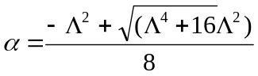8)

We use the same alpha for an alpha-beta filter, and additionally have the relationship:
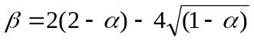
9)

COMPUTING THE TRACKING INDEX
Under steady state conditions the position maneuverability uncertainty is just the bar-to-bar variation of the mid range of the price bars. The measurement uncertainty is half the high-to-low range of the price bar. Simple enough. As a practical matter, is it better to take the Exponential Moving Averages of these two measurements to keep the Tracking Factor from going completely crazy. A smoothing constant of .2 results in reasonable a four bar lag in both the numerator and denominator, fundamentally canceling lag in the ratio. Therefore, the simplified equations for the Tracking Factor in terms of the price is:

- A = .2*((H+L)/2 – (H[1]+L[1])/2) + .8*A[1]
B = .2*(H-L)/2 + .8*B[1]
Λ = A / B
The EasyLanguage source code for an optimal tracking filter is given in SideBar1.

************************************** SideBar 1 *******************************************
EasyLanguage Code for an Optimal Tracking Filter

inputs: Price((h+l)/2);

vars: lambda(0),
alpha(0);

Value1 = .2*(Price - Price[1]) + .8*Value1[1];
Value2 = .1*(H - L) + .8*Value2[1];
if Value2 <>0 then lambda = AbsValue(Value1 / Value2);
alpha = ( -lambda*lambda + SquareRoot(lambda*lambda*lambda*lambda + 16*lambda*lambda)) /8;
Value3 = alpha*Price + (1-alpha)*Value3[1];

Plot1(Value3, "AlphaTrack");

OPTIMUM TRACKING FILTER EXAMPLE
Returning to the same price data used in Figure 1 to plot the zero lag filter, we see that the Optimum Tracking Filter quickly adjusts rapid shifts in the price and yet is relatively smooth when the price has a sideways action. The operation of this filter is similar to Kaufman’s Adaptive Moving Average. In this case, you know the filter is optimal for the given uncertainty in the price movement and the measurement of that movement. Notice how the tracking filter flattens in sideways market conditions. I conclude that this optimum tracking filter can lead to far fewer whipsaw signals. The simple Alpha Optimum Tracking Filter can be easily extended to an Optimum Alpha-Beta filter that has even tighter tracking. Which is better for trading? That’s where you come in. It is your project to imbed these optimum filters in your own indicators and trading systems.

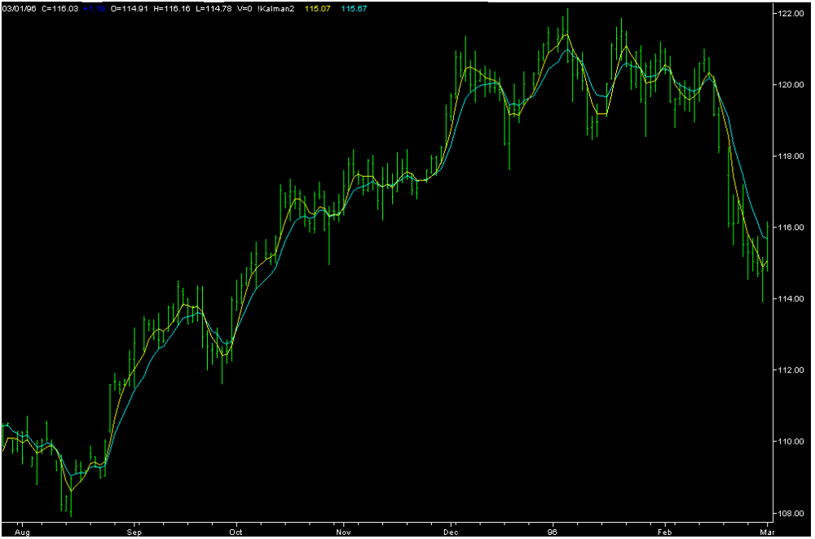

Figure 1. EMA (α = .25) and Zero Lag Moving Average
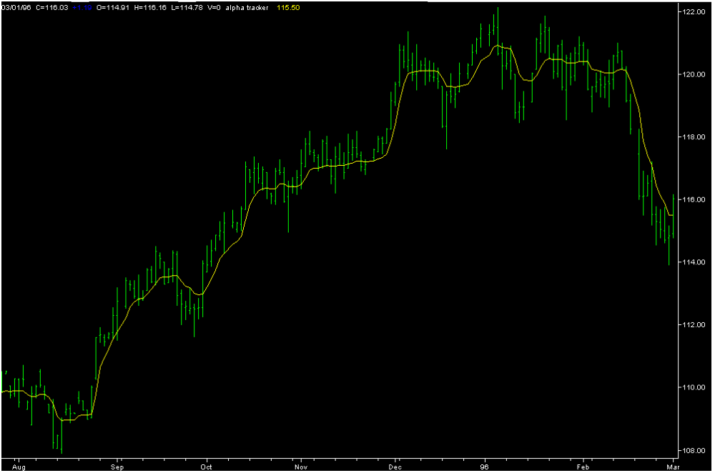

Figure 2. Optimum Tracking Filter

Paul R. Kalata, “The Tracking Index: A Generalized Parameter for α−β and α−β−γ Target Trackers”, IEEE Transactions on Aerospace and Electronic Systems”, Vol AES-20, No.2, March 1984, p 174-182
John Ehlers, “Signal Analysis Concepts”
Perry J. Kaufman, “Smarter Trading”, McGraw-Hill, 1995

